1)types of keys?

1)primary key?

2)candidate key

3)super key

4)foreign key

2)feature of sql?

3)difference b/w ddl and dml?

4)Constraint in sql?

Not null

Check

Unique

5)difference b/w alter and update?

6)difference b/w delete,truncate, drop?

7)group by and having clause?

8)about joins and type of joins?

Self join

Natural join

Left join

Right join

9)noramlisation ?

10)Differnc b/w 1nf,2nf,3nf,bcnf?

10)Acid properties?

11)what is indexing?

It is used in database .

By using indexing retrival is more fast

12)what are aggregate function?

Avg,count,min,max,sum

13)find max salary?

Select max salry from employee

14)find nth highst salary?

limit 0,1 - Top max salary

limit 1,1 - Second max salary

limit 2,1 - Third max salary

limit 3,1 - Fourth max salary

15)difference b/w truncate and delete command?

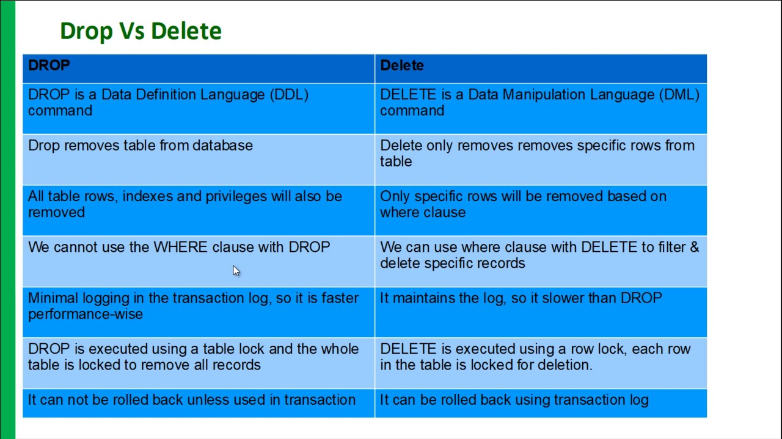

16) what is views in sql?

17)Explain primary key and foreign key?

Primary key:->it ensure the value in particular column is unique

Foreign key:-> it ensure the link b/w two table

18)what is primary key?

1)primary key is a field in a table which is uniquely identified each record in database

2)primary key must contain unique values

3)it column can not hav null values

19) diifernce b/w primary key and unique key?

